**College Database**

# Project Team (2 students)

|  |  |  |
| --- | --- | --- |
| **No** | Stu-Number | Name Surname |
| 1 | 17070001002 | Selin Çetiner |
| 2 | 17070001013 | Berkın Akbıyık |

**PHASE 2-Normalization and SQL Examples**

# Tables Design

* Fill the tables with at least 10 records (Any program you developed to fill the records automatically will bring additional points)
* Review the final design, and explain each functional dependencies one by one according to the tables
* Apply normalization rules (1NF,2NF,3NF)---All tables

## Admin

metin içeren bir resim

Açıklama otomatik olarak oluşturuldu

## Department

tablo içeren bir resim

Açıklama otomatik olarak oluşturuldu

## Faculty

metin içeren bir resim

Açıklama otomatik olarak oluşturuldu

## Grades

tablo içeren bir resim

Açıklama otomatik olarak oluşturuldu

## Lesson

metin, tablo içeren bir resim

Açıklama otomatik olarak oluşturuldu

## Student

tablo içeren bir resim

Açıklama otomatik olarak oluşturuldu

## Student_has_grades

tablo içeren bir resim

Açıklama otomatik olarak oluşturuldu

## Teacher

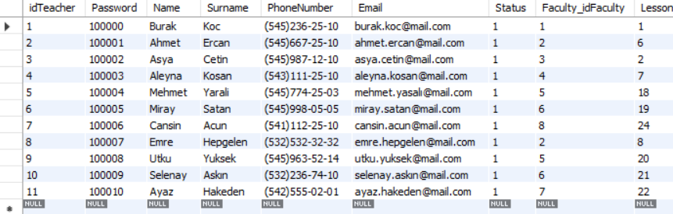

## Announcement

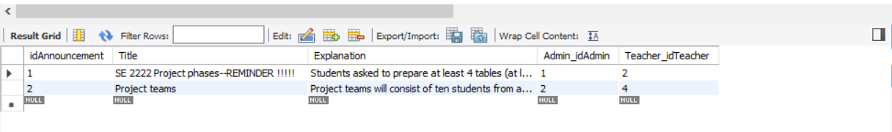

# Functional Dependencies

## Table 1 Name

## Table 2 Name

## Table 3 Name

## Table 4 Name

## Table x Name

## Table x Name

# Normalizations

Explain 1NF,2NF,3NF

Our database was created and filled according to the normalization rules.  
To be the database normalized in 1NF

Each table cell in the database contains a single value and each record should be unique.

To be the database normalized in 2NF

It is already should be in 1NF and there should be the single column primary key.

To be the database normalized in 3NF

It is already should be in 2NF and there should be no transitive functional dependencies

# SQL Examples

Show the syntaxes and give 2 examples for each

## SELECT ?

Select * from lesson;

Select stddev(quizGrade) from grades;

## DISTINCT ?

Select distinct name from student;

Select distinct hwgrade from grades;

## WHERE ?

Select id_faculty from faculty where department=Industrial Engineering;

Select name,surname from teacher where teacher_title IN(select max(teacher_title) from table ));

## AND/OR ?

Select surname from grades where (quizgrade=100) and (midtermgrade=70);

Select surname from grades where (finalgrade>75) or (hwgrade<70);

## BETWEEN

 Select* from grades where quizgrade between 10 and 20;

Select* from grades where finalgrade not between 25 and 85;

## ORDER BY ?

select name from teacher ORDER BY teacher_title asc;

select dept_id from lesson where title=5 ORDER BY Grade desc limit 5;

## GROUP BY?

Select count(name), class from student group by class;

Select count(Password), PhoneNumber from table group by PhoneNumber;